**C# Cumulative 3 Testing** **Screenshots**

1. **Successful Update:**

curl -X PUT "http://localhost:5215/api/teacher/3" \

-H "Content-Type: application/json" \

-d '{

"TeacherId":3,

"TeacherFName":"Linda",

"TeacherLName":"Chan",

"EmployeeNumber":"T382",

"HireDate":"2015-08-22",

"Salary":62.00,

"TeacherWorkPhone":"555-1234"

}'   
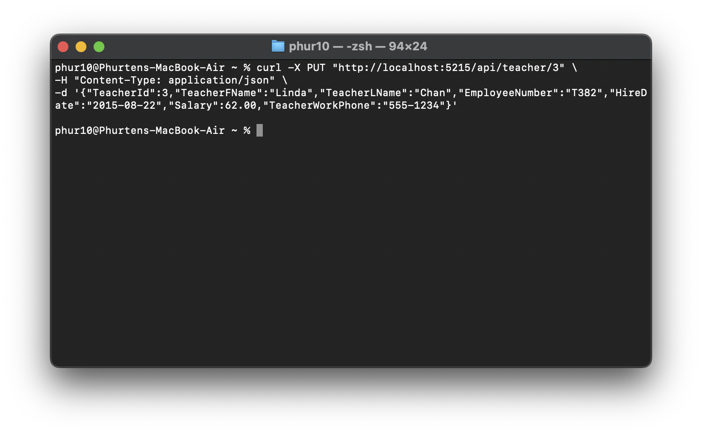

1. **Empty First Name**

curl -X PUT "http://localhost:5215/api/teacher/3" \

-H "Content-Type: application/json" \

-d '{

"TeacherId":3,

"TeacherFName":"",

"TeacherLName":"Chan",

"EmployeeNumber":"T382",

"HireDate":"2015-08-22",

"Salary":62.00,

"TeacherWorkPhone":"555-1234"

}'

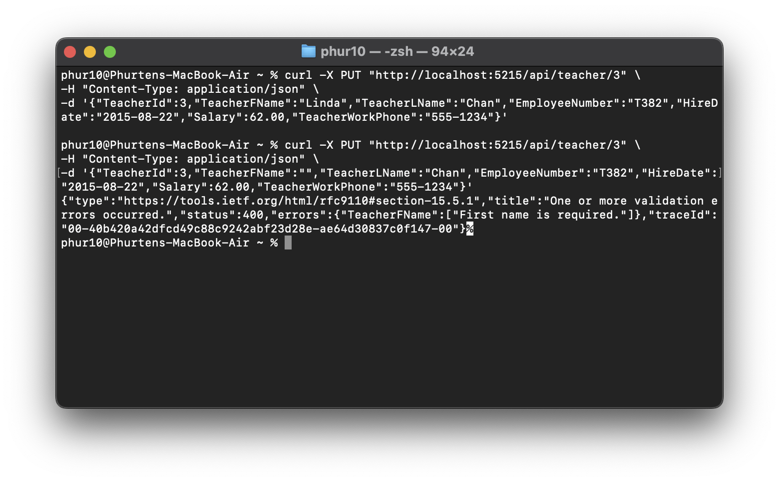

1. **Empty Last Name**

curl -X PUT "http://localhost:5215/api/teacher/3" \

-H "Content-Type: application/json" \

-d '{

"TeacherId":3,

"TeacherFName":"Linda",

"TeacherLName":"",

"EmployeeNumber":"T382",

"HireDate":"2015-08-22",

"Salary":62.00,

"TeacherWorkPhone":"555-1234"

}'

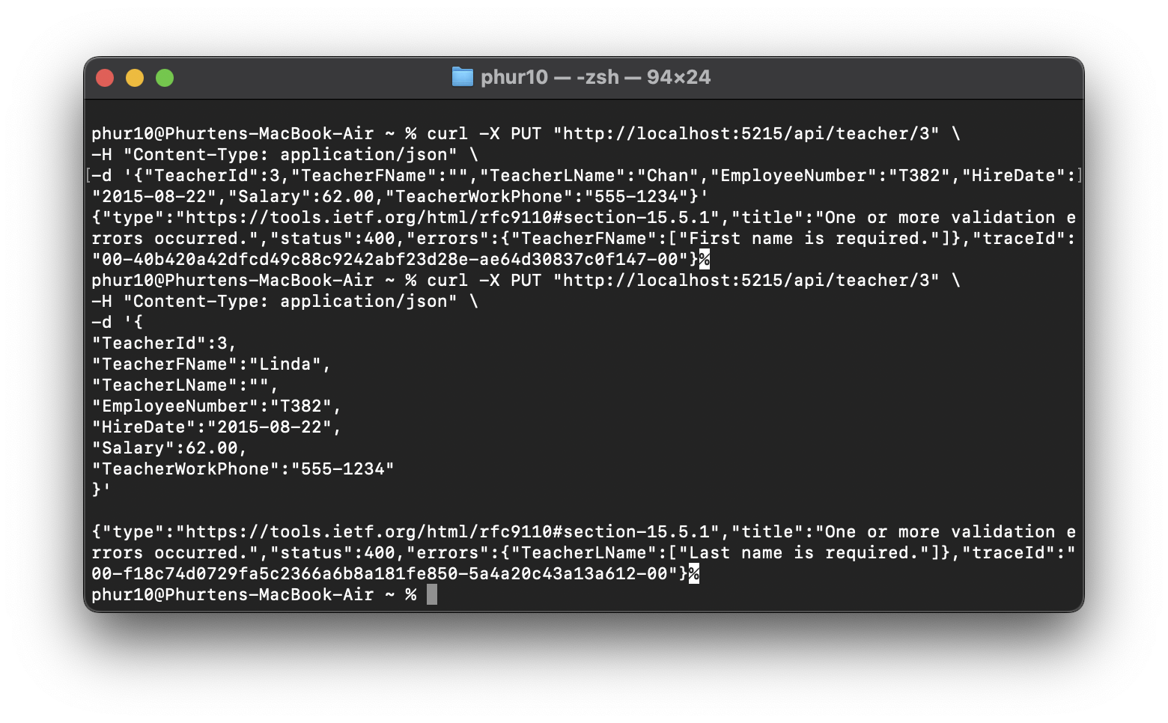

1. **Negative Salary**

curl -X PUT "http://localhost:5215/api/teacher/3" \

-H "Content-Type: application/json" \

-d '{

"TeacherId":3,

"TeacherFName":"Linda",

"TeacherLName":"Chan",

"EmployeeNumber":"T382",

"HireDate":"2015-08-22",

"Salary":-10,

"TeacherWorkPhone":"555-1234"

}'

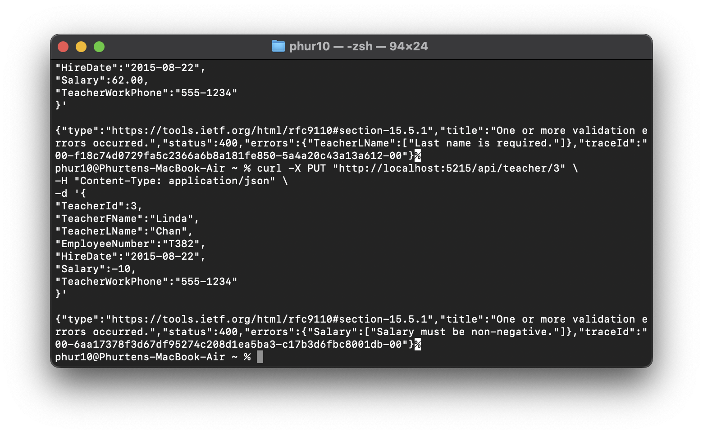

1. **Hire Date in the Future**

curl -X PUT "http://localhost:5215/api/teacher/3" \

-H "Content-Type: application/json" \

-d '{

"TeacherId":3,

"TeacherFName":"Linda",

"TeacherLName":"Chan",

"EmployeeNumber":"T382",

"HireDate":"2099-01-01",

"Salary":62.00,

"TeacherWorkPhone":"555-1234"

}'

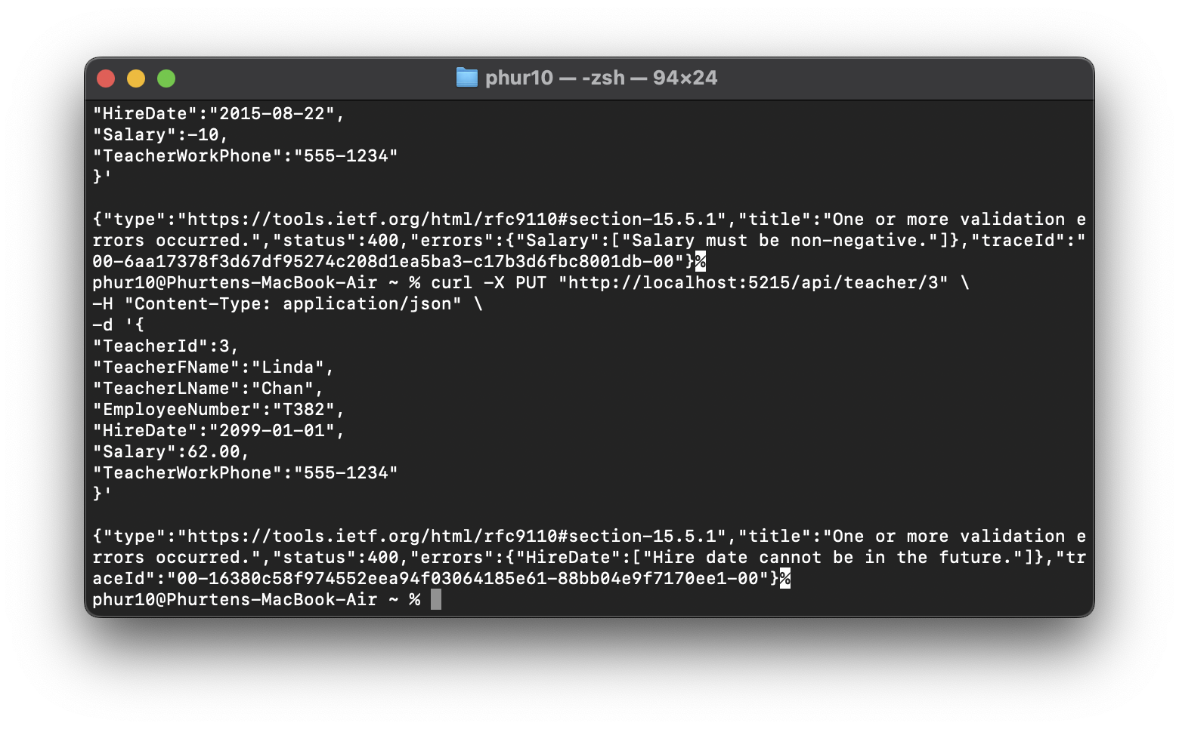

1. **Duplicate Employee Number**

curl -X PUT "http://localhost:5215/api/teacher/3" \

-H "Content-Type: application/json" \

-d '{"

TeacherId":3,

"TeacherFName":"Linda",

"TeacherLName":"Chan",

"EmployeeNumber":"T400",

"HireDate":"2015-08-22",

"Salary":62.00,

"TeacherWorkPhone":"555-1234"

}'

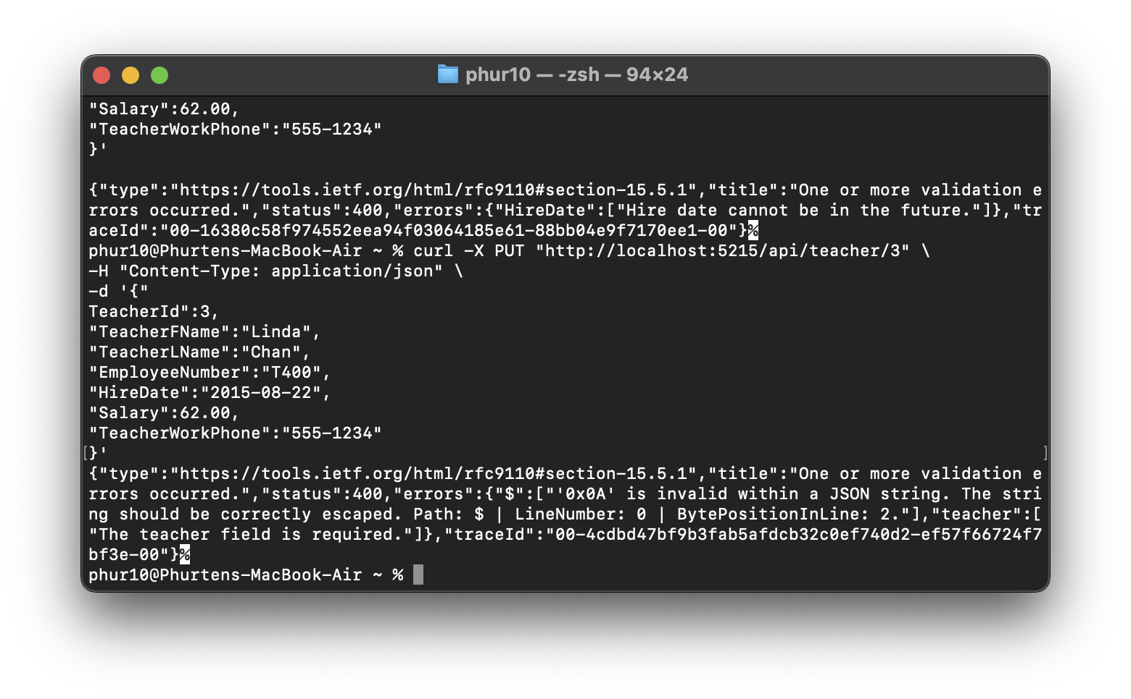

1. **Invalid Employee Number Format**

curl -X PUT "http://localhost:5215/api/teacher/3" \

-H "Content-Type: application/json" \

-d '{

"TeacherId":3,

"TeacherFName":"Linda",

"TeacherLName":"Chan",

"EmployeeNumber":"X123",

"HireDate":"2015-08-22",

"Salary":62.00,

"TeacherWorkPhone":"555-1234"

}'

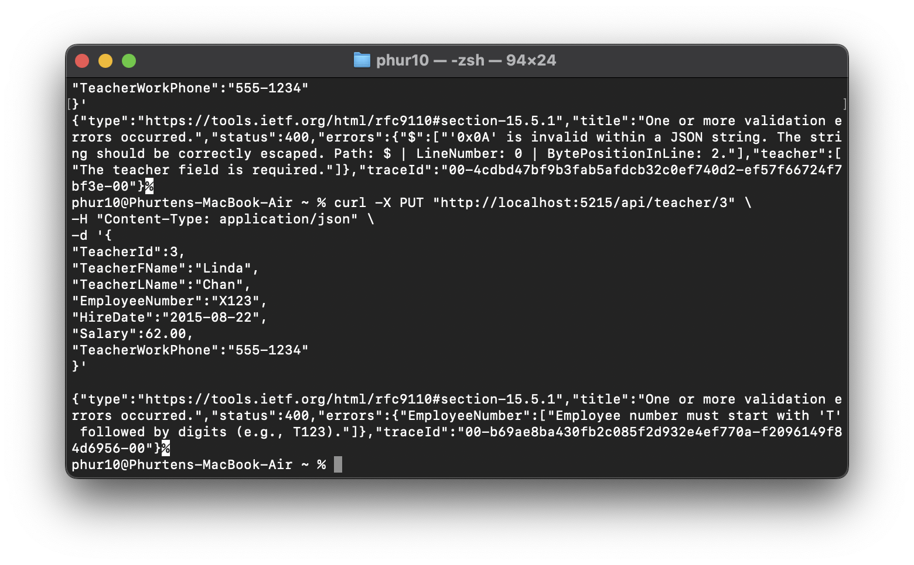

1. **Teacher Not Found**

curl -X PUT "http://localhost:5215/api/teacher/9999" \

-H "Content-Type: application/json" \

-d '{

"TeacherId":9999,

"TeacherFName":"Linda",

"TeacherLName":"Chan",

"EmployeeNumber":"T999",

"HireDate":"2015-08-22",

"Salary":62.00,

"TeacherWorkPhone":"555-1234"

}'

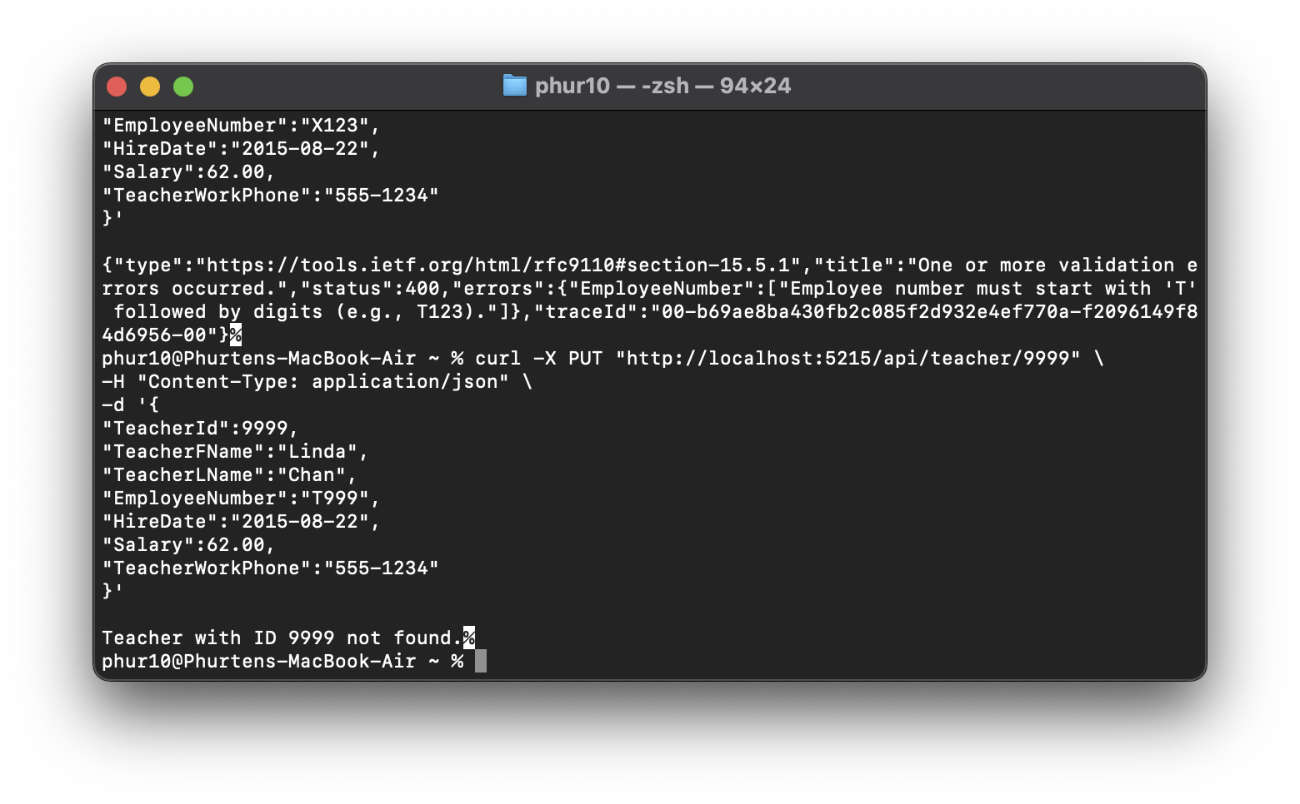

1. **ID Mismatch**

curl -X PUT "http://localhost:5215/api/teacher/3" \

-H "Content-Type: application/json" \

-d '{

"TeacherId":4,

"TeacherFName":"Linda",

"TeacherLName":"Chan",

"EmployeeNumber":"T382",

"HireDate":"2015-08-22",

"Salary":62.00,

"TeacherWorkPhone":"555-1234"

}'

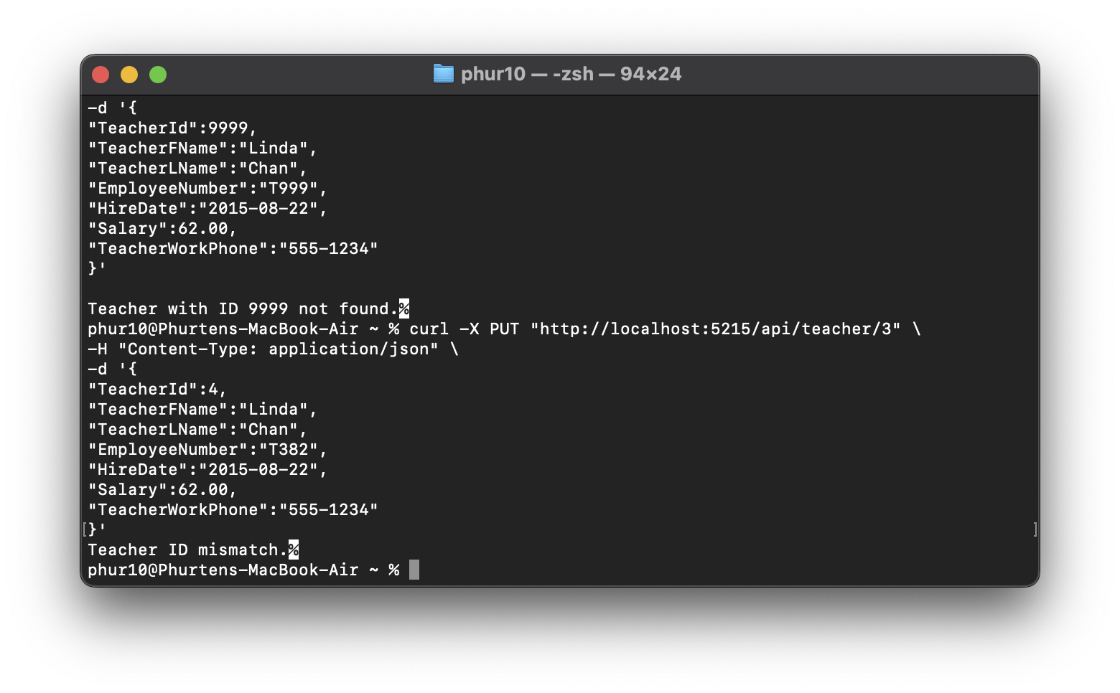

**Web Successful Update (Salary changed to 88.00)**

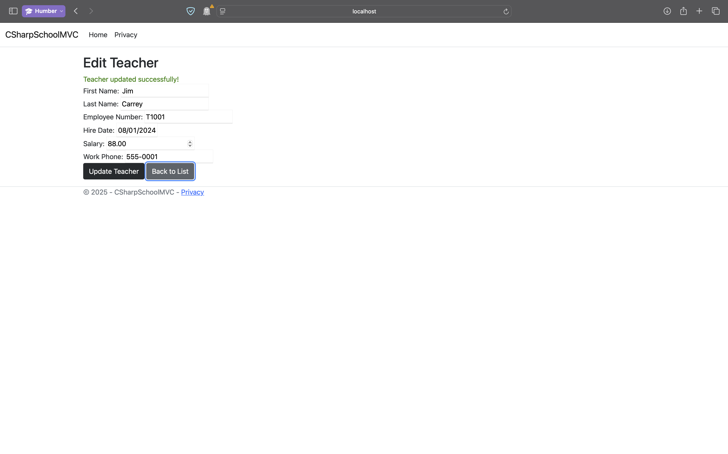  
  
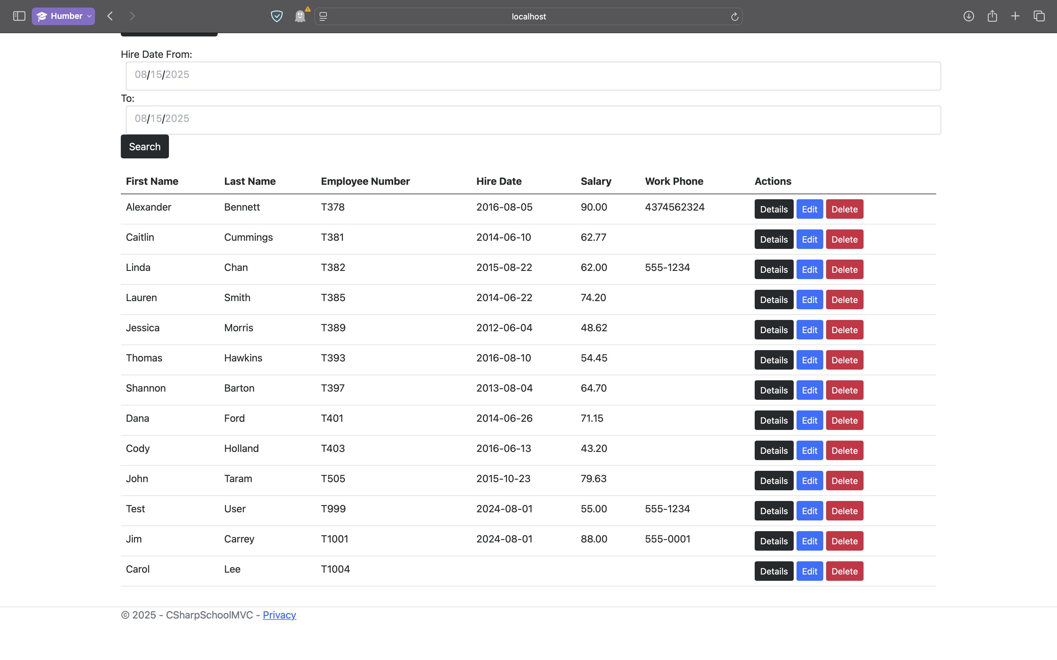

**Empty First Name**  
  
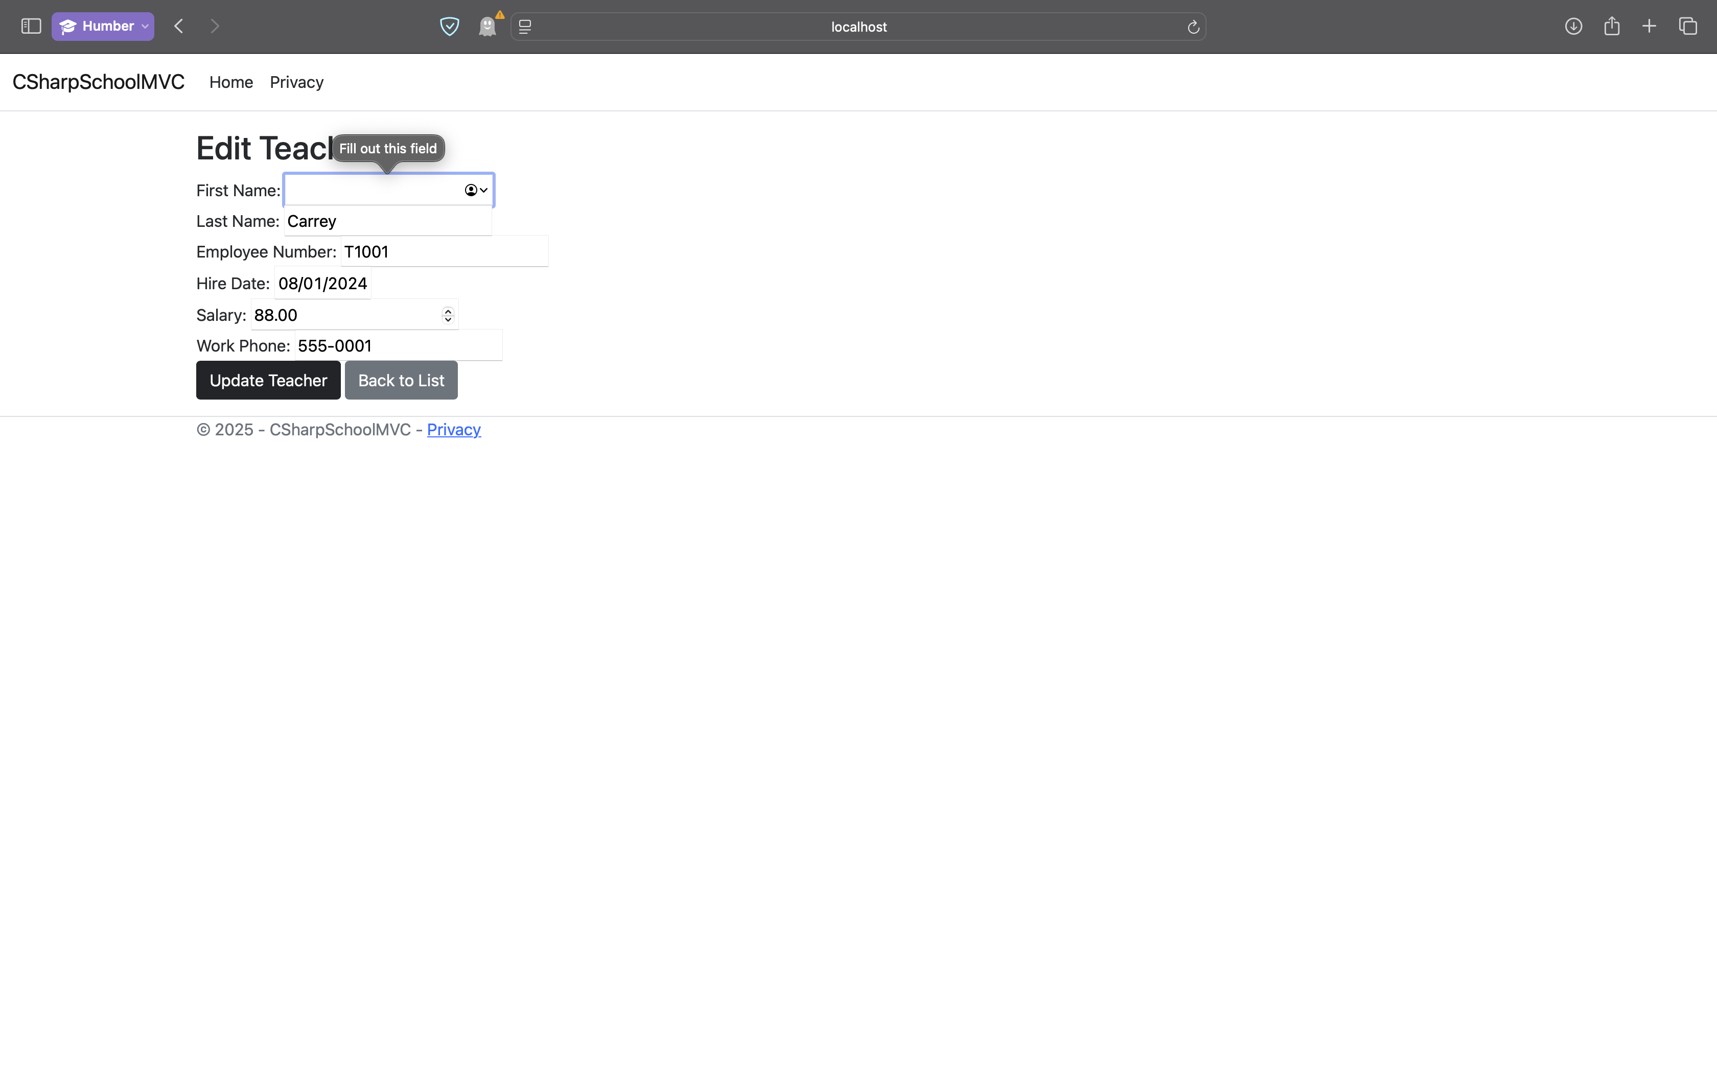

**Empty Last Name**

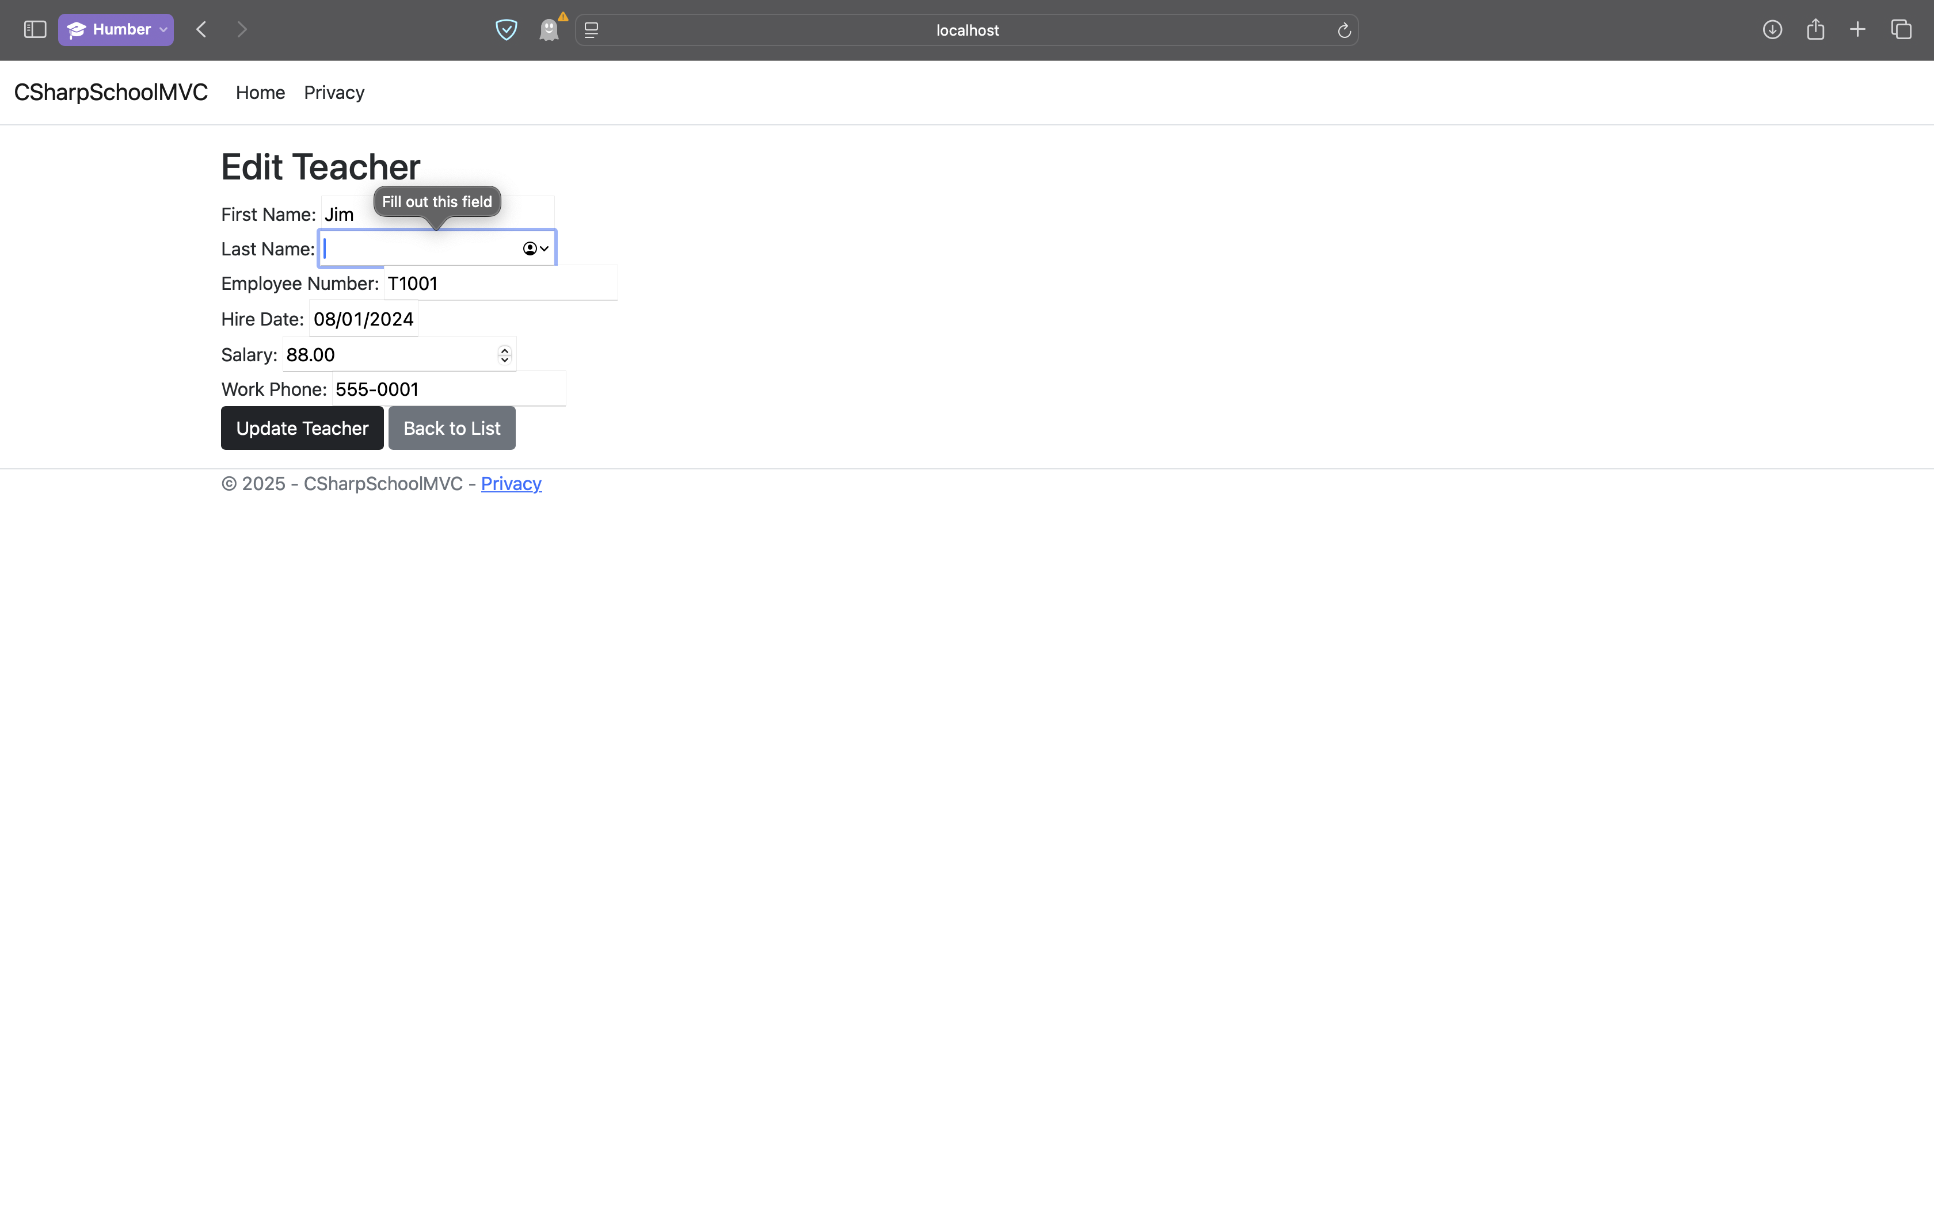

**Negative Salary**

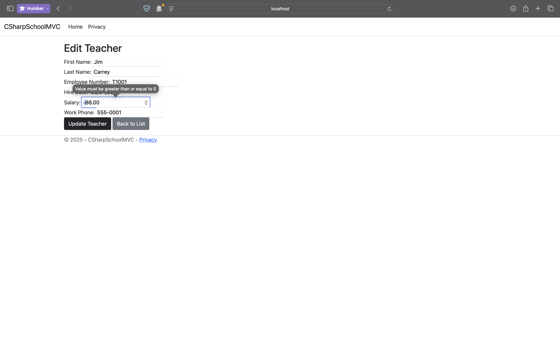

**Future Hire Date**

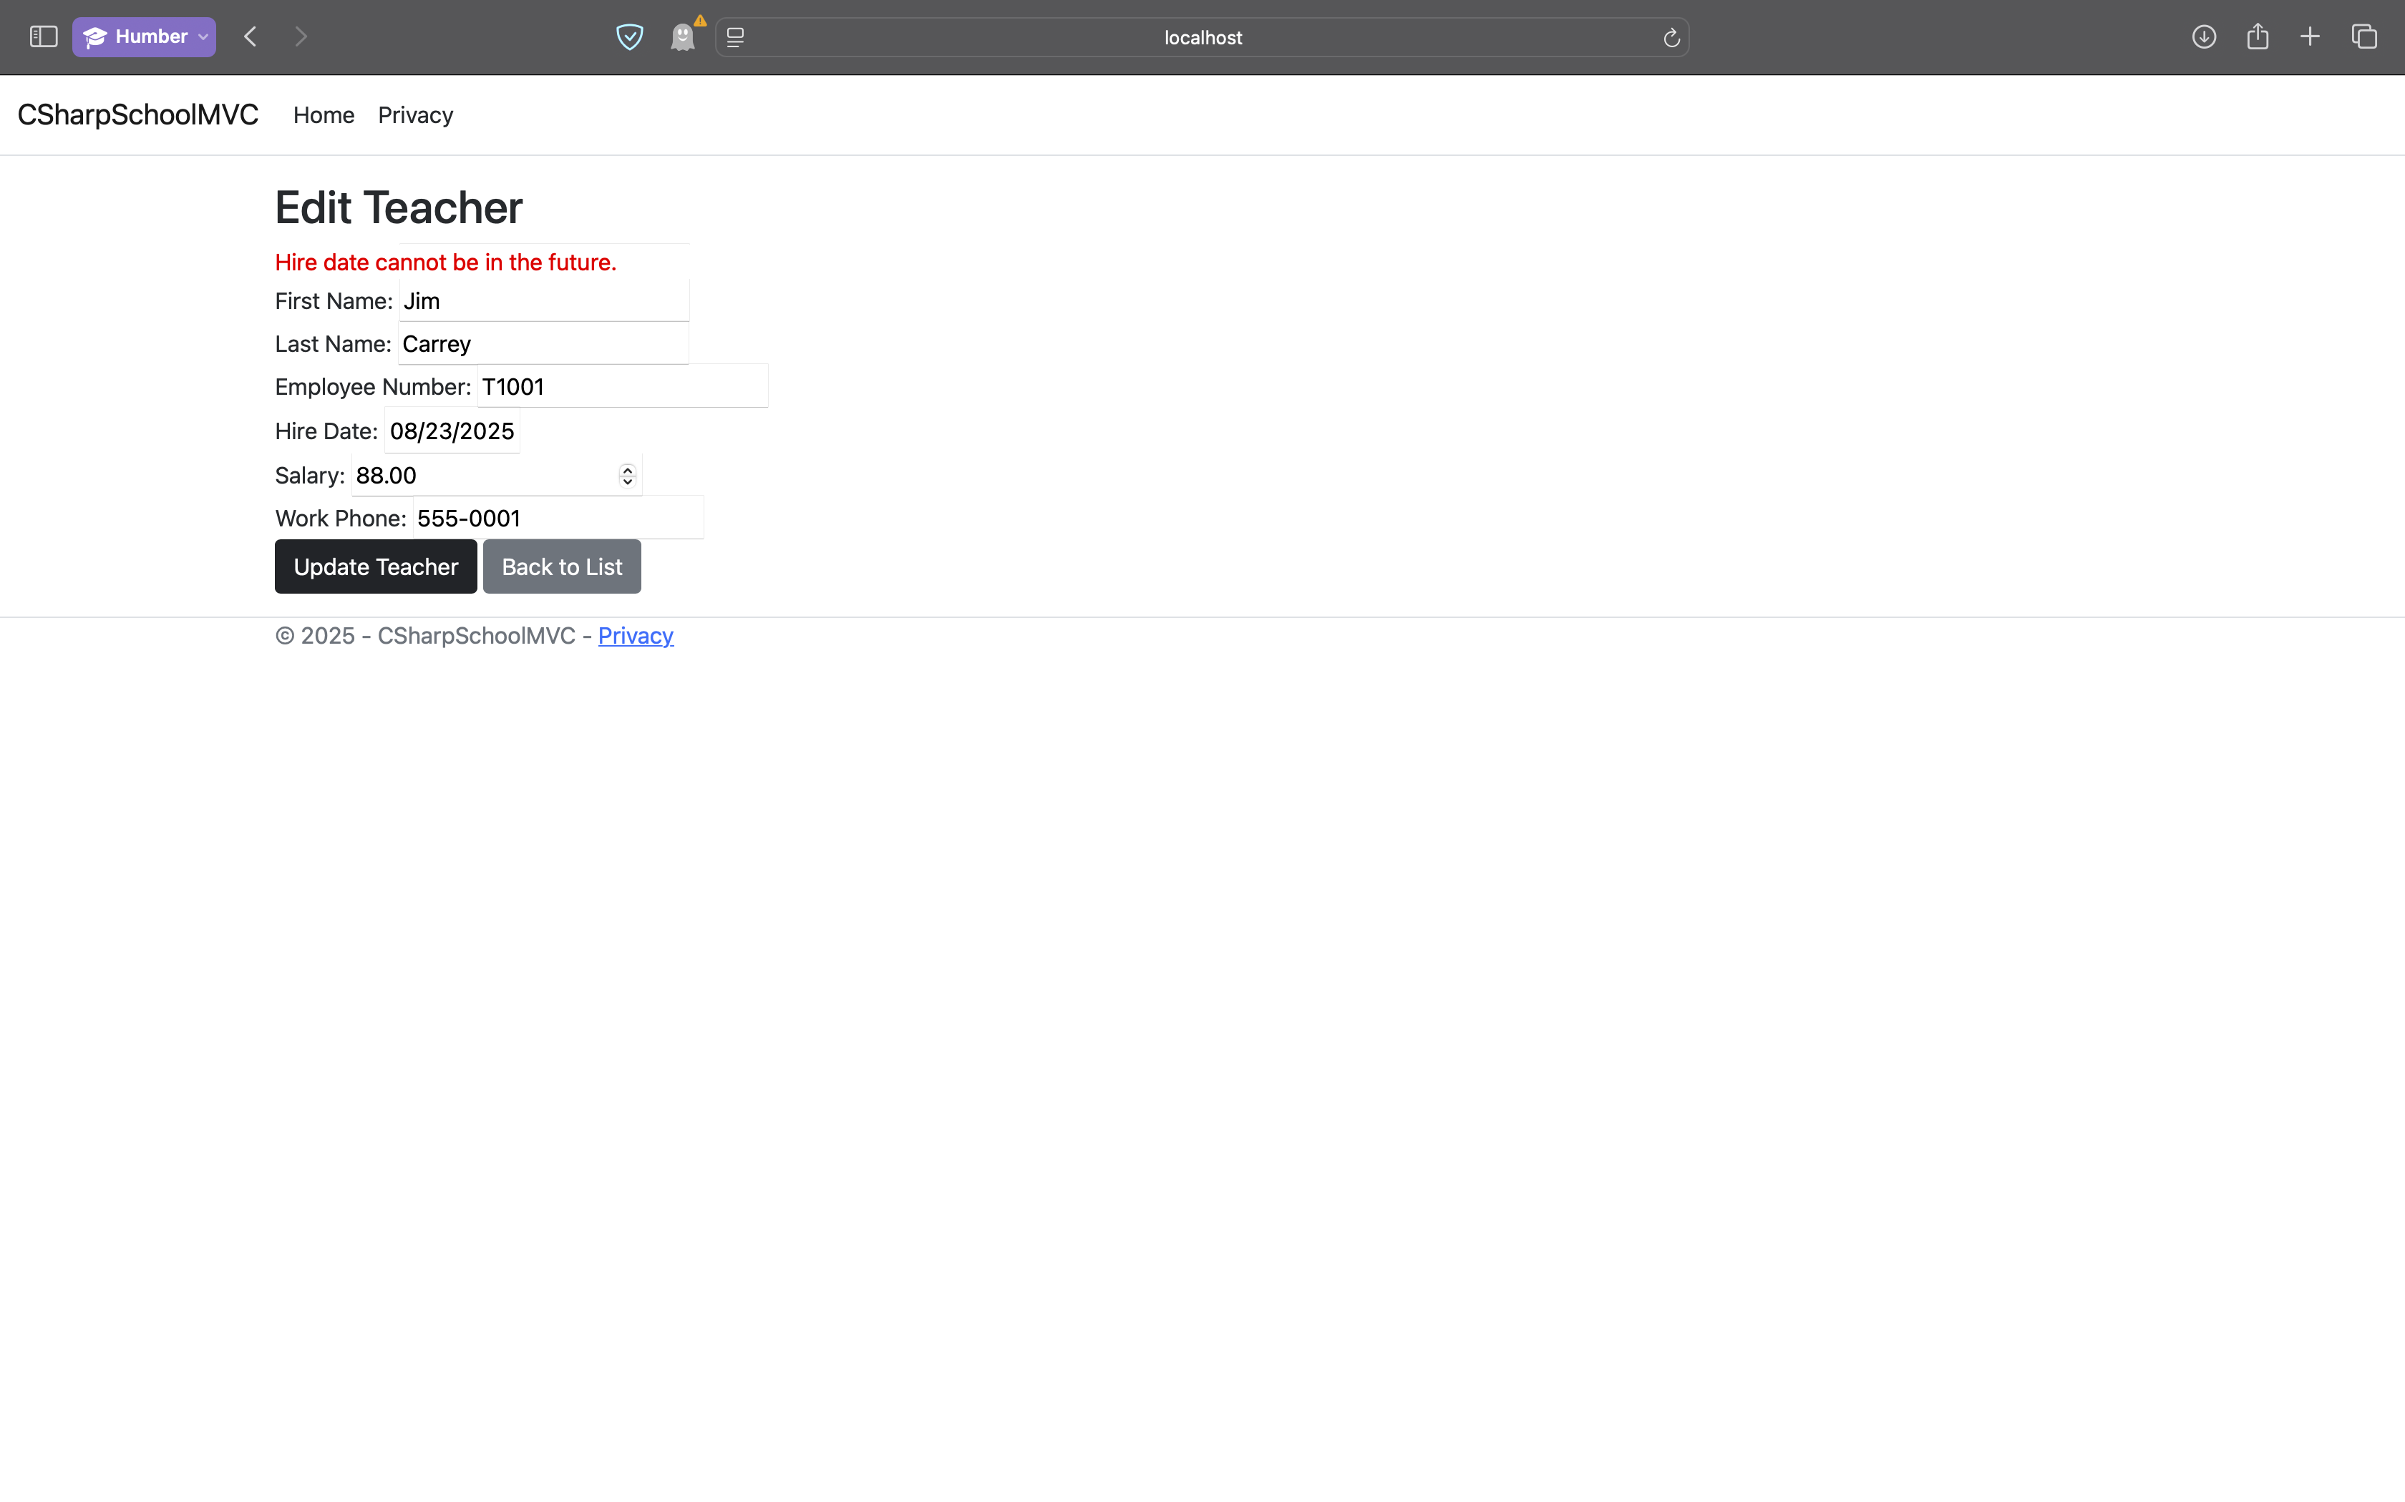

**Invalid Employee Number Format**

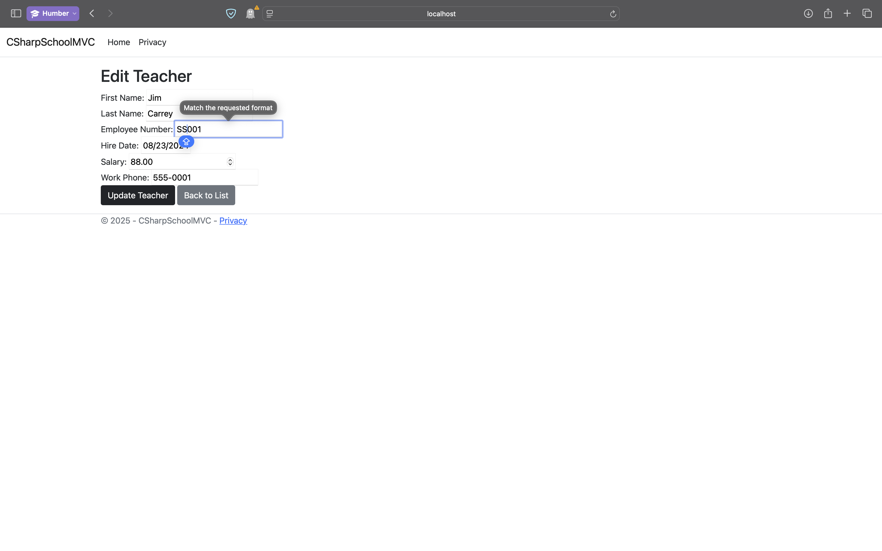

**Duplicate Employee Number**

